**JUMPIN’ JUNE   
3-DAY SMACKDOWN**

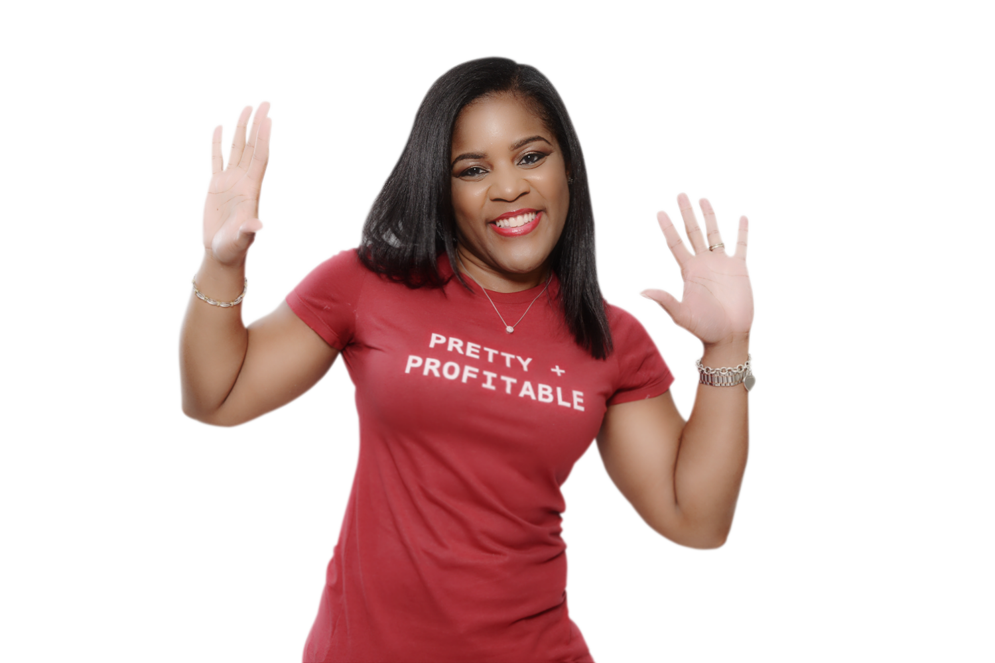

**SMACKDOWN WERKBOOK**

Disclaimer: The information contained herein is general in nature and for informative purposes only. It is based on the author’s personal experience. The author assumes no responsibility whatsoever, under any circumstances, for any actions taken as a result of the information contained herein.

**Copyright © 2017. BAAB Writing and Marketing Services LLC. All Rights Reserved.** No part of this document may be reproduced or shared without express, written consent from the author.

Contents

DAY 1: GIVE THE PEOPLE WHAT THEY WANT 4

DAY 2: “PIMP” FACEBOOK 5

DAY 3: “TRICKIN’ AIN’T EASY 6

BONUS: BANGIN’ TOOLS AND RESOURCES 7

MEET YOUR MILLION-DOLLAR WORD STYLIST 8

# DAY 1: GIVE THE PEOPLE WHAT THEY WANT

What is the first thing you should always do before launching a new product?

______________________________________________________________________________________________________________________________________________________________________________________________________

What was my greatest takeaway from today?

______________________________________________________________________________________________________________________________________________________________________________________________________

How will completing today’s WERK IT NOW assignment move me closer to my goal of hitting my June business goals?

______________________________________________________________________________________________________________________________________________________________________________________________________

**ACTION TIME!** What will I DO differently within the next 3 to 5 days to boost my brand awareness and generate more leads and revenue?

________________________________________________________________________________________________________________________________________________________________________________________________________________________________________________________________________

# DAY 2: “PIMP” FACEBOOK

What is Apryl’s top secret for using Facebook to promote digital products and services?

______________________________________________________________________________________________________________________________________________________________________________________________________

How will I use what I learned from Apryl today to attract more leads and make more money in my business?

____________________________________________________________________________________________________________________________________

How will completing today’s WERK IT NOW assignment move me closer to my goal of writing in a way that propels folks to whip out their credit cards and smack the buy button?

______________________________________________________________________________________________________________________________________________________________________________________________________

**ACTION TIME!** What will I DO differently within the next 3 to 5 days to boost my brand awareness and generate more leads and revenue?

______________________________________________________________________________________________________________________________________________________________________________________________________

# DAY 3: “TRICKIN’ AIN’T EASY

How has Apryl been able to “trick” Facebook and use the platform to promote her products and services even without investing in ads?

______________________________________________________________________________________________________________________________________________________________________________________________________

How will I use what I learned from Apryl today to attract more leads and make more money in my business?

______________________________________________________________________________________________________________________________________________________________________________________________________

What was my greatest takeaway from today?

______________________________________________________________________________________________________________________________________________________________________________________________________

**ACTION TIME!** What will I DO differently within the next 3 to 5 days to boost my brand awareness and generate more leads and revenue?

______________________________________________________________________________________________________________________________________________________________________________________________________

# BONUS: BANGIN’ TOOLS AND RESOURCES

Tune in LIVE every day on Periscope, Instagram and Facebook at 3 p.m. EST for surprise bonuses, resources and so much more to help you master the art of boosting engagement and socially selling.

# MEET YOUR MILLION-DOLLAR WORD STYLIST

Apryl Beverly, the “Million-Dollar Word Stylist” and founder of **BAAB Writing and Marketing Services**, crafts copy that has generated millions in revenue for solo entrepreneurs and some of the top brands in the United States.

Known for her educated, “tell-it-like-it-is” writing style, she recently hit the Amazon Top 5 Best Seller’s List in 3 categories just 24 hours after releasing her first book, “Shots Fired! How to Write Copy that Pierces Hearts (And Opens Wallets).”

Her recent book, *F.A.S.T. Money!* shot to the No. 1 spot on the Amazon Best Seller’s List 24 hours BEFORE the book’s official release!

In addition to being a sentence slinger, Apryl is a mom to the most amazing kid in the universe and is married to the masterful “money man.”

Learn more about Apryl at [baab.biz](http://www.baab.biz) and download her first bestselling book at [shotsfired.co](http://WWW.SHOTSFIRED.CO). You can grab your copy of *F.A.S.T. Money!* [here](http://www.fastmoneybook.co).